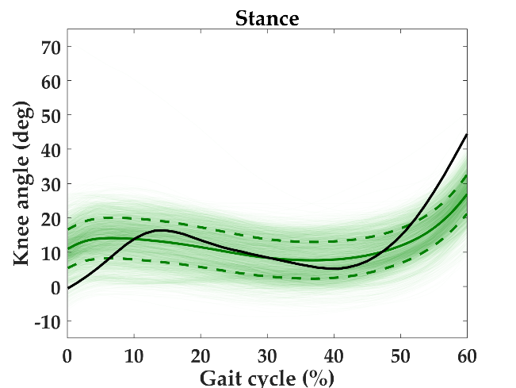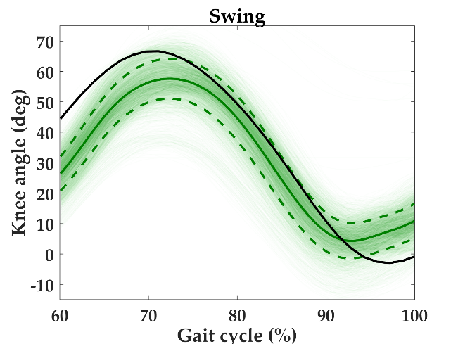

**Supplementary Figure 1.** Knee position for stance (3218 steps) and swing (3165 steps) phases aggregated across legs for all steady-state level walking steps for all subjects. The solid and dashed green lines represent mean ± one standard deviation. The solid black line represents data from Winter (1983) for one representative gait cycle.

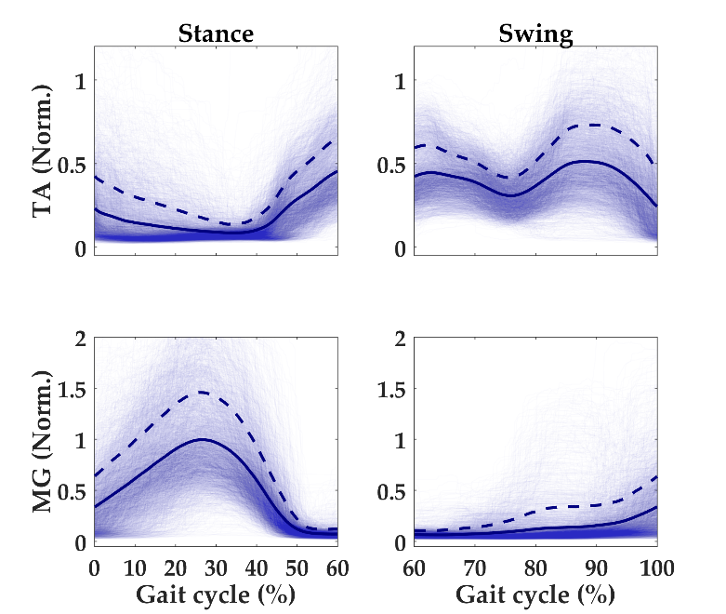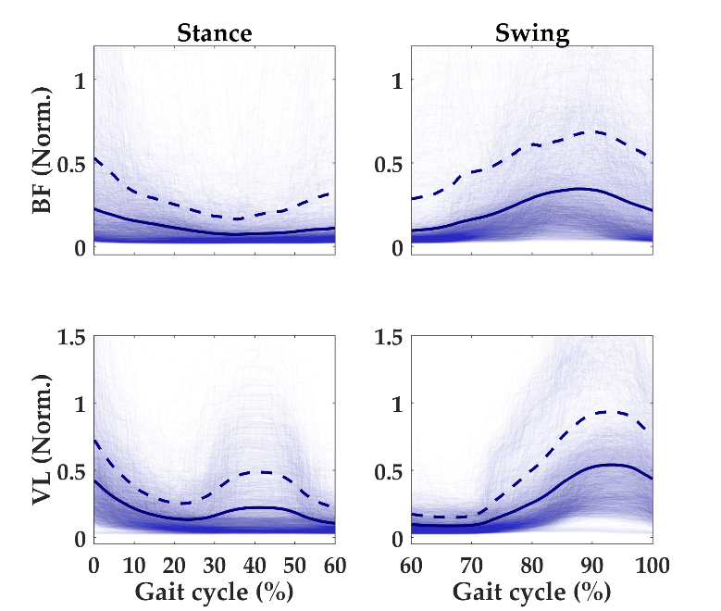

**Supplementary Figure 2.** Muscle activation (EMG normalized for each subject by the RMS voltage during MVC trials) for stance (3218 steps) and swing (3165 steps) phases aggregated across legs for all steady-state level walking steps for all subjects. The muscles shown are tibialis anterior (TA), medial gastrocnemius (MG), biceps femoris (BF), and vastus lateralis (VL). The solid and dashed blue lines represent mean + one standard deviation.